The Capay Valley Energyshed
Draft – QUICK and PRELIMINARY - Summary of Results

California began significantly reshaping energy policy starting with the Global Warming Solutions Act of 2006 (AB 32), which requires greenhouse gas emissions be reduced to 1990 levels by 2020. With similar national initiatives likely to be developed over the next few years, achieving greater sustainability will require a substantial shift in the way we think about energy generation and use. This summary presents the major findings of the Capay Valley Energyshed Study, a local initiative to lay the groundwork for long-term, sustainable systems and to position the Valley community as a leader in developing the new low-carbon economy.

Currently, northern California in general and Capay Valley in particular are heavily reliant on large-scale, centralized energy sources delivered in most part from Pacific Gas and Electric (PG&E). For communities such as Capay Valley, this translates to energy generated and purchased from external sources that control consumer pricing and may not be as focused on the development of renewable resources. There are both security and economic consequences of single-distribution system, including lost revenue and a concentrated supply source. Under certain energy flow scenarios in which Valley renewable resources are efficiently deployed, the energy supply system can be reconfigured into one that has greater energy security, reduces long-term effects of climate change and at least partially retains economic benefits within the Capay Valley (Figure 1b).

a)
b)

Figure 1: Current and Regionally Optimized Energy Flows. In a) large amounts of energy are currently purchased from external sources, resulting in a loss of local income and an accumulation of large amounts of carbon in the atmosphere, in b) a reconfigured energy system would include energy efficiency measures coupled with the development of renewable energy from local resources that allow for all energy needs to be provided for locally. Additionally, adjustments to land-use practices with carbon sequestration in mind can offset any remaining GHG emissions. Capay Valley fulfills the roles of energy producer, energy user and carbon sink.
CAPAY VALLEY

The Capay Valley is a 25,000-acre, mostly rural area in Yolo County, located in northern California. The Valley rests “between the Blue Hills of the Vaca Mountains and the Rumsey Hills” and includes Cache Creek, a key surface irrigation source. The Valley has been the home of Native American tribes for hundreds of years, starting before the Mexican and then American settlements were developed in the mid-1800s. In 2000, the Valley population of 4,552 persons was comprised largely of white or Hispanic residents, and included the Rumsey Band of Wintun Indians and some African American families that settled in the area decades ago. The largest single employer in the Valley is the Cache Creek Casino Resort, with the agricultural industry as another key contributor to the local economy. Figure 2 illustrates the recent crop diversity in Capay Valley, which includes both conventional and organic growers.

State Highway 16 is a major thoroughfare that runs along the length of the Valley. Interstate 505 forms part of the eastern border of the Valley. Recent development plans for the Valley include projects that will help direct heavy traffic flow along Highway 16 away from the town centers to promote downtown revitalization. The major unincorporated towns in Capay Valley, Brooks, Capay, Esparto, Guinda, Madison and Rumsey, are located along Highway 16. The most populated town, Esparto, had a population of 1,858 according to the 2000 census.

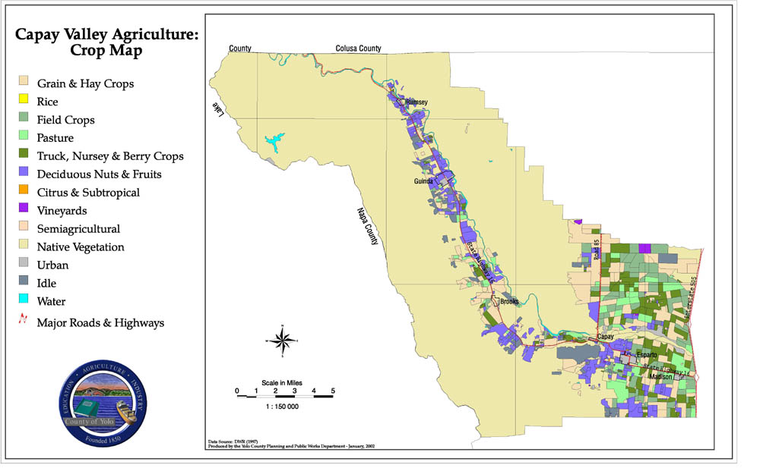
Figure 2: Capay Valley Crop Map

Current Renewable Energy Production
Renewable energy development in the Capay Valley region potentially could include contributions from most of the major resources. Optimal gross annual potential exceeds a power generating capacity of 2,600 MW and 5 TWh (5,287,042 MWh) of electrical energy. Solar, including maximum available rooftop deployment, and wind constitute the largest potentials, although land use competition and other constraints are likely to reduce capacity well below these estimated gross potentials. A somewhat more realistic approximation includes only solar capacity estimates based on rooftop areas and wind in regions of class 4 and above. This reduces the total potential to about 35 MW and 0.1 TWh (101,424 MWh). To put this information in context, the state of California has estimated that approximately 7,000 MW of eligible renewable resources can be economically developed statewide by 2010.
Biomass generating capacity is comparable to wind in the latter analysis but the energy potential is about 2.5 times higher because of the difference in estimated capacity factor, biomass supplying baseload power as compared with the intermittency of wind and solar. At this time, based on current assessments, hydro and geothermal resources are expected to contribute only small amounts to the total renewable resources; further analyses are needed as these potentially could contribute substantially more than has currently been identified. Energy conversion other than to electricity is also possible, for example biomass might be used in the future to produce up to about 2 million gallons gasoline equivalent per year of biofuels, possibly more if suitable energy crops are developed. Understanding how the regional can use optimally utilize these resources will depend on specific siting and economic assessments, but the region is fortunate in having a diverse resource base to support more sustainable development.

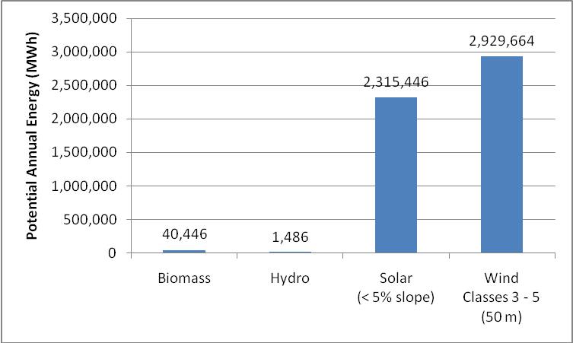
Figure 1. Estimated Potential Annual Energy (MWh). Notes: Geothermal capacity is uncharacterized at present; the existing identified resource lies outside the Valley study area. Based on recent analysis for the Capay diversion dam only, additional potential hydro capacity requires more detailed analysis

Current Residential Energy Use (Electricity Only)

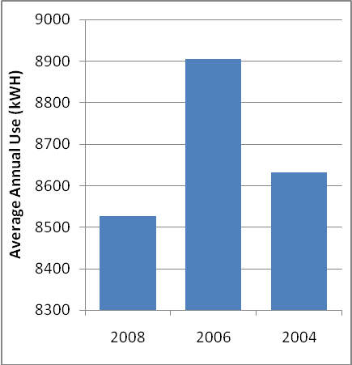
Here, we report consumption estimates using energy use data provided by PG&E. While PG&E was able to provide energy consumption data, the resolution of that data was constrained by the geographic boundaries in which confidentiality levels could be maintained. While this restricts a detailed analysis, the results reflected here represent reasonable estimates of annual (Figure 2) and seasonal use (Figure 3).
Figure 2. Average Annual Residential Electricity Use (From roughly 2200 residential meters)

The average annual demand ranged between 8600 kWH/yr (2008) to as high 8900kWH/yr in 2006. The seasonal patterns are as expected, with higher electricity use in the summer months and slightly higher use in the winter months. To put these estimates in context, the average CA household uses between 4,800 and 9,600 kWh per year.

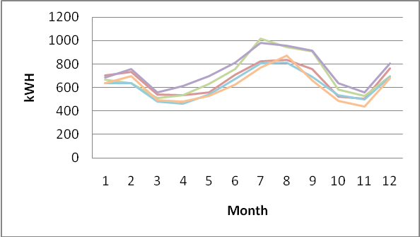
Figure 3. Average seasonal household electricity use (by zipcode, 2008)
This preliminary assessment suggests that it is potentially feasible to generate sufficient renewable energy within the Capay Valley to offset current residential electricity now purchased through PG&E. What remains to be explored is how the Valley can organize to both purchase and utilize PG&E’s basic system for transmission and delivery of renewables generated within the Valley.

These results may be adjusted as the report findings are fine-tuned and edited into a final version.
arb.ca.gov/cc/cc.htm
www.dpla2.water.ca.gov/publications/groundwater/bulletin118/basins/pdfs_desc/5-21.68.pdf
www.dpla2.water.ca.gov/publications/groundwater/bulletin118/basins/pdfs_desc/5-21.68.pdf page 1
capayvalleyvision.org/capayvalley.html
capayvalleyvision.org/capayvalley.html
yolocounty.org/Index.aspx?page=321 Chart G
Capay Valley Atlas: Resource Information for the Capay Valley-Esparto Region edited by Ann Scheuring
sacog.org/regionalfunding/awarded_grant_applications--2005-07.cfm Esparto Downtown Revitalization Project
factfinder.census.gov
capayvalleyvision.org/maps.html
PG&E supplies energy use data for community and government related operations provided that the specified level of resolution (e.g., zipcode) includes at least 15 customers, or no single customer with greater than 15% of the total load for that resolution. An exception to this rule is for those customers in which a prior release is obtained. This constraint obviously protects the privacy of individual users, but as will be discussed in the main report, also limits the ability to design markets in which major uses could be targeted.

