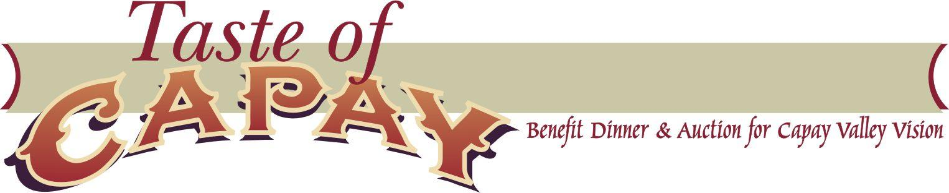
Sponsorship Levels & Benefits 2019

“Health, Beauty, and Permanence
in the Capay Valley”

$10,000 or above Oak
- PR/Media coverage
- Poster recognition at the event (large font)
- Capay Valley Vision website posting
- Event program recognition
- 2 tables

$5,000 or above Elderberry
- PR/Media coverage
- Poster recognition at the event (medium font)
- Capay Valley Vision website posting
- Event program recognition
- 1 table

$2500 or above Yerba Santa
- PR/Media coverage
- Poster recognition at the event (small font)
- Capay Valley Vision website posting
- Event program recognition
- 6 tickets

$1000 or above Willow
- Poster recognition at the event
- Capay Valley Vision website posting
- Event program recognition
- 4 tickets

$500 or above Coyote Mint
- Poster Recognition at the event
- Capay Valley Vision website posting
- Event program recognition
- 2 tickets

Please contact Caitlin Zavala: Caitlin.zavala2@gmail.comfor more information.
Thank you!

Capay Valley Vision is a California-based 501c3 nonprofit corporation and donations are tax deductible to the extent allowable by law. Our federal tax ID number is 68-0472371.

